Some notes: [Udacity](https://www.notion.so/Front-End-Track-b2e3839f46924858949650dc6ec467ac)

1. **HTML –** [**really good notes on W3schools**](https://www.w3schools.com/html/html_elements.asp)

**And** [**devdocs.io**](https://devdocs.io/)

The HTML document is divided in two parts – head tag and body tag.

There are closing tags and open tags like br, img, hr etc. There are some tags for adding images, for tables and lists , formatting etc.

There is an interesting tag called DIV, this is used to give structure to the HTML code, it helps to divide the webpage in several sections which allows us to develop highly customisable code.

**HTML Attributes:**

All HTML elements can have attributes

The href attribute of <a> specifies the URL of the page the link goes to

The src attribute of <img> specifies the path to the image to be displayed

The width and height attributes of <img> provide size information for images

The alt attribute of <img> provides an alternate text for an image

The style attribute is used to add styles to an element, such as color, font, size, and more.

We can use border [colour](https://www.w3schools.com/colors/colors_names.asp), background colour and text colours in each element, like heading, paragraph table etc as an attribute.

The lang attribute of the <html> tag declares the language of the Web page

The title attribute defines some extra information about an element

**HTML Paragraph tags:**

<p> Defines a paragraph

<hr> Defines a thematic change in the content

<br> Inserts a single line break

<pre> Defines pre-formatted text

**Formatting tags:**

<b> - Bold text or <strong> - Important text  
<i> - Italic text or <em> - Emphasized text  
<mark> - Highlighted text  
<small> - Smaller text  
<del> - Strike Through text  
<ins> - Inserted text or underlined  
<sub> - Subscript text  
<sup> - Superscript text

**Quotation Elements:**

<abbr> Defines an abbreviation or acronym [hover to see full-form]

<address> Defines contact information for the author/owner of a document [italics only]

<bdo> Defines the text direction

<blockquote> Defines a section that is quoted from another source

<cite> Defines the title of a work

<q> Defines a short inline quotation

**Image tags:**

1. Image map: The <map> tag is used to define an image map. An image map is an image with clickable areas.The required name attribute of the <map> element is associated with the [<img>](https://www.w3schools.com/tags/tag_img.asp)'s usemap attribute and creates a relationship between the image and the map.The <map> element contains a number of [<area>](https://www.w3schools.com/tags/tag_area.asp) elements, that defines the clickable areas in the image map.  
   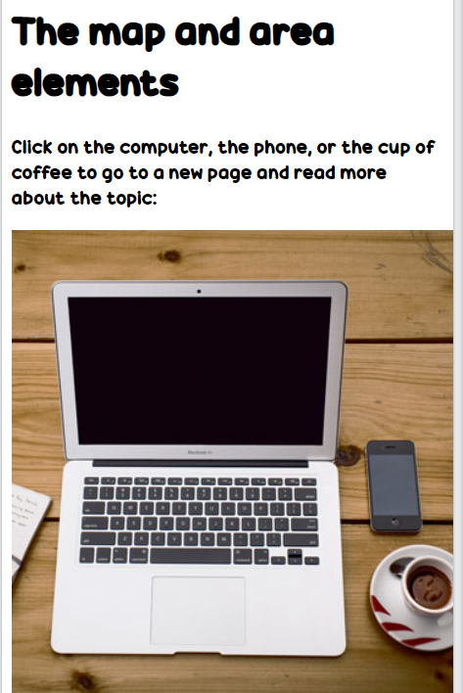 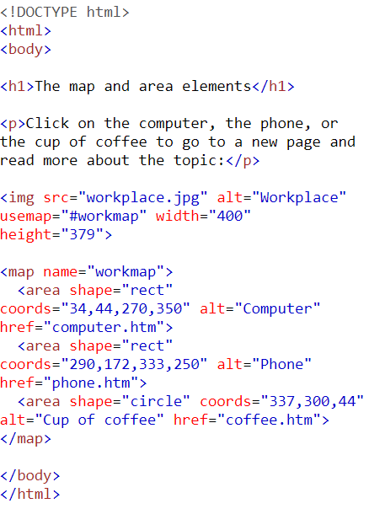
2. Picture tag element:  
   The HTML <picture> element gives web developers more flexibility in specifying image resources.The <picture> element contains one or more <source> elements, each referring to different images through the srcset attribute. This way the browser can choose the image that best fits the current view and/or device. Each <source> element has a media attribute that defines when the image is the most suitable.
3. Area tag defines a clickable zone inside an image. <img src="workplace.jpg" alt="Workplace" usemap="#workmap" width="400" height="379">  
     
   <**map name="workmap">  
     <area shape="rect" coords="34,44,270,350" alt="Computer" href="computer.htm">  
     <area shape="rect" coords="290,172,333,250" alt="Phone" href="phone.htm">  
     <area shape="circle" coords="337,300,44" alt="Cup of coffee" href="coffee.htm">**  
   </map>

**Table tags:**

The table element has th, *tr, td and table*  for table heading table row, table data CELL and table respectively. It has several attributes you can change.

<table> Defines a table

<th> Defines a header cell in a table

<tr> Defines a row in a table

<td> Defines a cell in a table

<caption> Defines a table caption

<colgroup> Specifies a group of one or more columns in a table for formatting

<col> Specifies column properties for each column within a <colgroup> element

<thead> Groups the header content in a table

<tbody> Groups the body content in a table

<tfoot> Groups the footer content in a table

**Embeddng a page:**It is used to display a page in another page.

<iframe src="url" title="description"></iframe>

**ViewPort Settings:**

Setting The Viewport

The viewport is the user's visible area of a web page. It varies with the device - it will be smaller on a mobile phone than on a computer screen. You should include the following <meta> element in all your web pages: <meta name="viewport" content="width=device-width, initial-scale=1.0">

**Base element:**

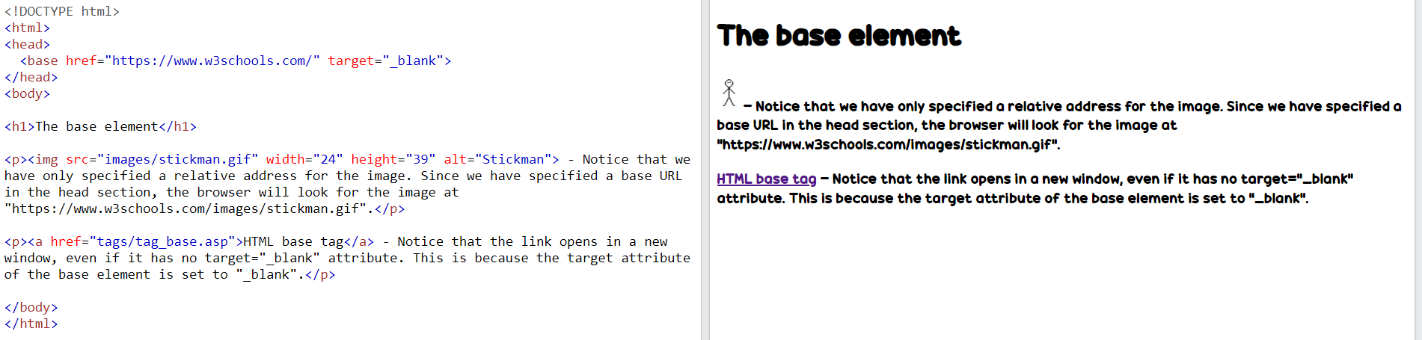

**Semantic Elements in HTML**

Below is a list of some of the semantic elements in HTML.

**Tag Description**

<article> Defines independent, self-contained content

<aside> Defines content aside from the page content

<details> Defines additional details that the user can view or hide

<figcaption> Defines a caption for a <figure> element

<figure> Specifies self-contained content, like illustrations, diagrams, photos, code listings, etc.

<footer> Defines a footer for a document or section

<header> Specifies a header for a document or section

<main> Specifies the main content of a document

<mark> Defines marked/highlighted text

<nav> Defines navigation links

<section> Defines a section in a document

<summary> Defines a visible heading for a <details> element

<time> Defines a date/time

[**Entities:**](https://www.w3schools.com/html/html_entities.asp)There are certain characters which are reserved in HTML, and they can not be used as they convey some meaning to the browser as an HTML code. Hence, entities are used for displaying them as content.

## URL ENCODING:

Web browsers request pages from web servers by using a URL. A Uniform Resource Locator (URL) is used to address a document (or other data) on the web. A web address ike <https://www.w3schools.com/html/default.asp> follows these syntax rules: **scheme://prefix.domain:port/path/filename**

Explanation:

* **scheme** - defines the **type** of Internet service (most common is **http or https**)
* **prefix** - defines a domain **prefix** (default for http is **www**)
* **domain** - defines the Internet **domain name**(like w3schools.com)
* **port** - defines the **port number**at the host (default for http is **80**)
* **path** - defines a **path** at the server (If omitted: the root directory of the site)
* **filename** - defines the name of a document or resource

[**HTML FORMSSSS: Very important to study.**](https://www.w3schools.com/html/html_forms.asp)I did not write it here because there is a lot of information and everything seems important.